2018 Land Use Liability Seminar

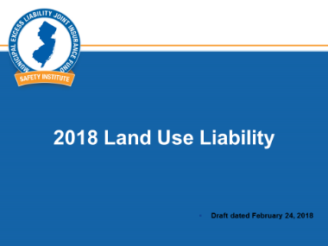
Slide 1 – Host introduces speaker(s)

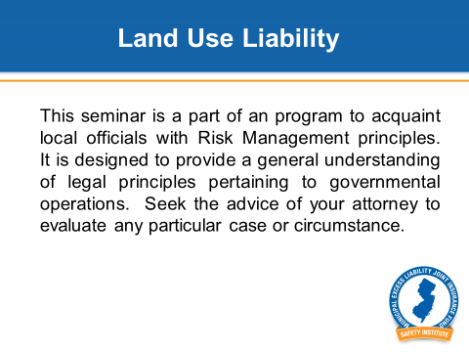
Slide 2 – This seminar is a part of a program to acquaint local officials with Risk Management principles. It is designed to provide a general understanding of the legal principles pertaining to governmental operations. Seek the advice of your attorney to evaluate any particular case or circumstance.

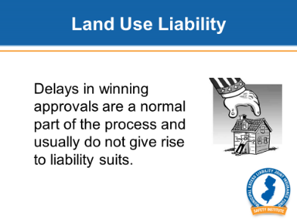
Slide 3 - The topic for this seminar is Land Use Liability. Fortunately, most applicants who have been denied approval do not sue for monetary damages. Delays in winning approvals are a normal part of the process and do not usually give rise to liability suits. This even includes Mt. Laurel cases. The appeal is to the Superior Court for injunctive relief, which is a court order that requires the municipality to take action or prohibits the municipality from taking action.

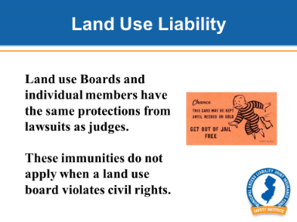
Slide 4 – The reason land use disputes rarely become liability claims against municipalities is because of the broad immunities extended to governmental decision makers. Land use is a judicial function and has the same broad immunities as a court. In fact, individual members of land use boards have the same protections from lawsuits as judges. However, these immunities do not apply when a land use board violates civil rights.

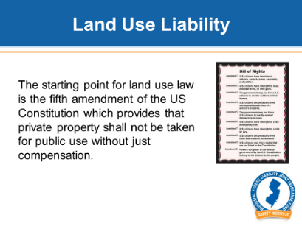
Slide 5 –The starting point for land use law is the fifth amendment of the US Constitution which provides that private property shall not be taken for public use without just compensation. Simply, when a governmental entity condemns private property for public use, it must pay the owner.

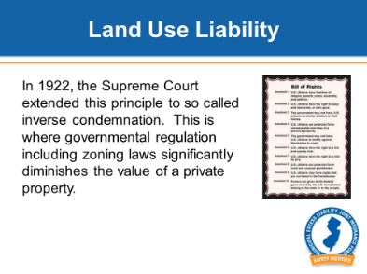
Slide 6 - In 1922, the Supreme Court extended this principle to so called inverse condemnation. This is where governmental regulations including zoning laws significantly diminishes the value of a private property. While government does not actually acquire ownership of the property, the laws or regulations adopted by the governmental entity effectively make the property worthless.
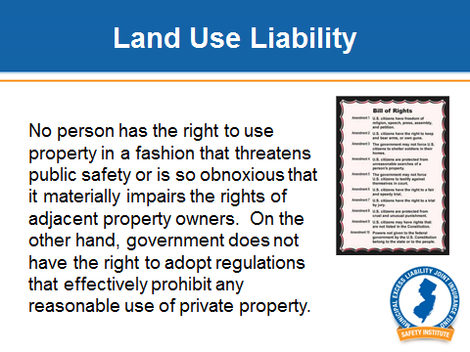
Slide 7 - Under the law, no person has the right to use property in a fashion that threatens public safety or is so obnoxious that it materially impairs the rights of adjacent property owners. On the other hand, government does not have the right to adopt regulations that effectively prohibit any reasonable use of private property.
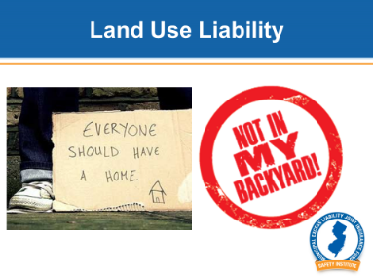
Slide 8 – Further, various Federal and state laws now give civil rights protection to a range of unpopular uses….in other words, NIMBY…. Not In My Backyard. For example, there have been numerous law suits involving group homes.

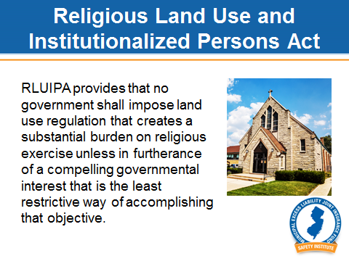
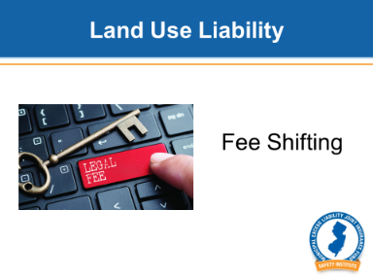
Slide 9 - What makes these cases especially expensive is attorney fee-shifting. If you lose a normal liability case, you pay the plaintiff and you pay your attorney’s bills. In a fee shifting case, you pay the plaintiff, you pay your attorney AND you pay the plaintiff’s attorney. Further, the plaintiff’s attorney is not paid a percentage of the award, but rather a fee based on the number of hours spent on the case PLUS an additional amount to compensate the attorney for the risk of losing the case. As a result, plaintiff’s attorneys often build up the number of hours if they believe they have a good chance of winning. It is not usual for the plaintiff’s attorney to be awarded an amount far higher than the plaintiff.

Slide 10 – For example, there has been extensive litigation in recent years under the Religious Land Use and Institutionalized Persons Act, known as RLUIPA. In one recent case here in New Jersey, a mosque was awarded damages of $7.5 million including $5 million for the mosque’s attorneys. Unanimously adopted by Congress in 2000, this act provides that no government shall impose land use regulation that creates a substantial burden on religious exercise unless in furtherance of a compelling governmental interest that is the least restrictive way of accomplishing that objective. These applications can be very controversial and because of fee shifting very expensive.

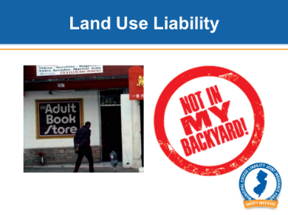
Slide 11 - Another example are cases concerning adult book stores and movie theaters. Under the first amendment, government cannot regulate the content of speech, but under some circumstances can regulate the side effects. In one case, Schad v. Mount Ephraim (1981), the US Supreme Court overturned a zoning ordinance that prohibited adult book stores and theaters because the zoning ordinance allowed a broad range of other uses in its commercial zone. Therefore, the court decided that this ordinance singled out a particular type of speech, objectionable as it is.

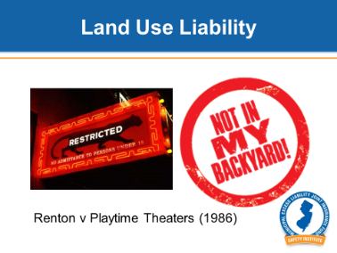
Slide 12 - Just a few years later in Renton v Playtime Theaters (1986) the same court upheld a zoning ordinance that prohibited adult theaters within 1000 feet of a residential zone. In this case, the court ruled that municipalities can take into consideration the higher crime rate around these establishments and use the zoning code to establish a buffer from residential areas so long as there are still places within the zone where these establishments could locate. Saying that, I would be very careful before adopting any zoning or building regulation that has the effect of singling out any particular type of speech.

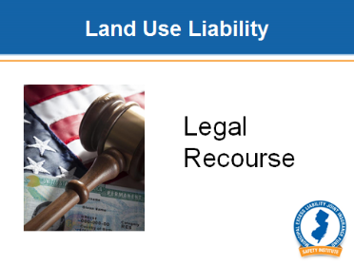
Slide 13 - Therefore, an applicant who has been denied approval normally does not have recourse to sue for monetary damages. The appeal is to the Superior Court for injunctive relief. However, monetary damages can be awarded in cases where the applicant’s civil rights have been violated and these damages include the applicant’s legal fees. That is why these cases almost always involve big numbers.

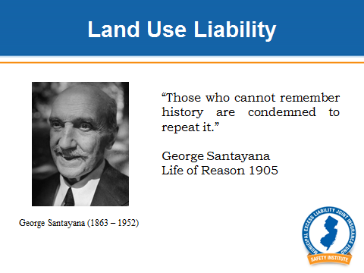
Slide 14 - Now comes the interesting part of this seminar ….the case studies. As philosopher George Santayana said:

“Those who cannot remember history are condemned to repeat it.”

As we go through the 10 case studies, you will decide the issue that was presented to the court. Each of these cases can be found on the MEL’s website that can be accessed through the app.

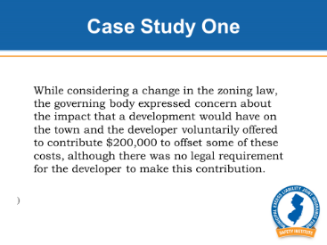
Slide 15 - In the first case, while considering a change in the zoning law, the governing body expressed concern about the impact that a development would have on the town and the developer voluntarily offered to contribute $200,000 to offset some of these costs, although there was no legal requirement for the developer to make this contribution.
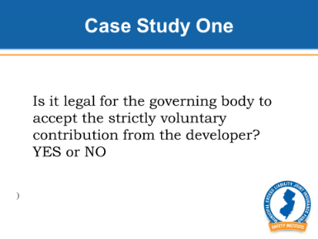
Slide 16 - Is it legal for the governing body to accept the strictly voluntary contribution from the developer? YES or NO (pause)

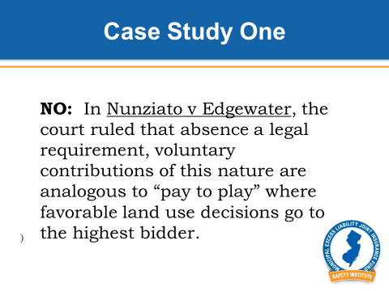
Slide 17 – NO: In Nunziato v Edgewater, the court ruled that absence a legal requirement, voluntary contributions of this nature are analogous to “pay to play” where favorable land use decisions go to the highest bidder. As a result of this 1988 case, communities are now required to establish specific requirements for offsite improvements.
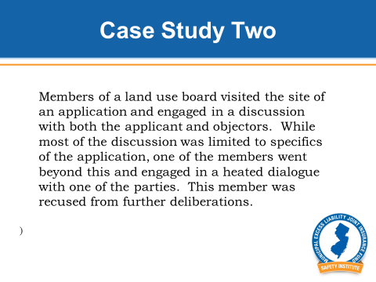
Slide 18: In the second case, members of a land use board visited the site of an application and engaged in a discussion with both the applicant and objectors. While most of the discussion was limited to specifics of the application, one of the members went beyond this and engaged in a heated dialogue with one of the parties. This member was recused from further deliberations.

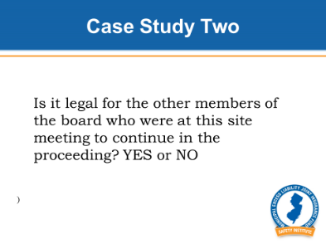
Slide 19 – Is it legal for the other members of the board who were at this site meeting to continue in the proceeding? YES or NO (pause)

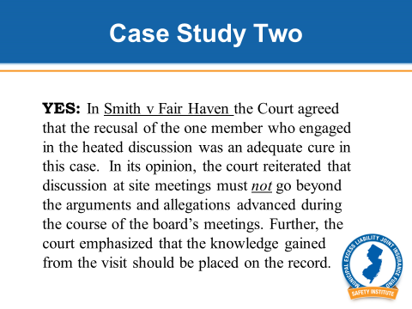
Slide 20 - YES: In Smith v Fair Haven the Court agreed that the recusal of the one member who engaged in the heated discussion was an adequate cure in this case. In its opinion, the court reiterated that discussion at site meetings must not go beyond the arguments and allegations advanced during the course of the board’s meetings. Further, the court emphasized that the knowledge gained from the visit should be placed on the record. For this reason, it is good practice to have the Board attorney at on site meetings.

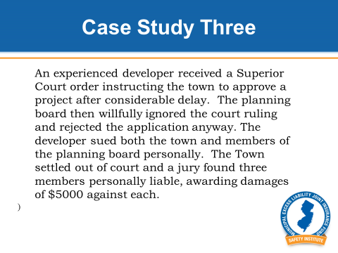
Slide 21 - In the third case, an experienced developer received a Superior Court order instructing the town to approve a project after considerable delay. The planning board then willfully ignored the court ruling and rejected the application anyway. The developer sued both the town and members of the planning board personally. The Town settled out of court and a jury found three members personally liable, awarding damages of $5000 against each.

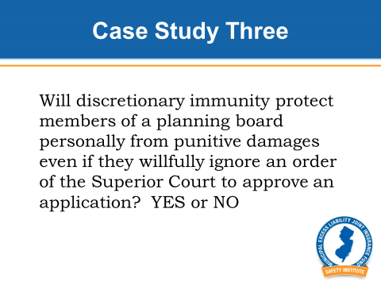
Slide 22 - Will discretionary immunity protect members of a planning board personally from punitive damages even if they willfully ignore an order of the Superior Court to approve an application? YES or NO (pause)

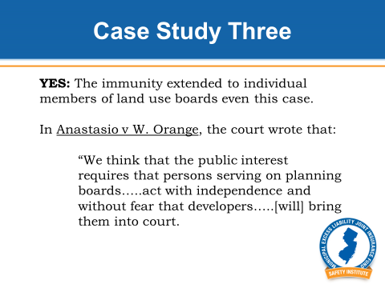
Slide 23 - YES: The immunity extended to individual members of land use boards even this case.

In Anastasio v W. Orange, the court wrote that:

“We think that the public interest requires that persons serving on planning boards…..act with independence and without fear that developers…..[will] bring them into court.

As a result, the members of the board were personally immune, but the town itself was still be held liable for their actions.

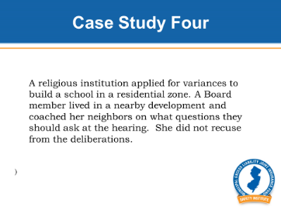
Slide 24 - In the fourth case, a religious institution applied for variances to build a school in a residential zone. A Board member lived in a nearby development and coached her neighbors on what questions they should ask at the hearing. She did not recuse from the deliberations.

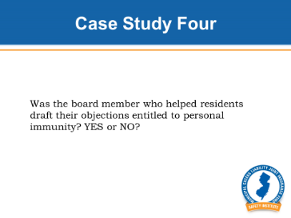
Slide 25 – Question 4: Was the board member who helped residents draft their objections entitled to personal immunity? YES or NO (pause)

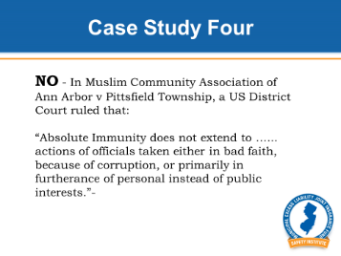
Slide 26 – NO: In Muslim Community Association v Ann Arbor, a US District Court held that:

“Absolute Immunity does not extend to …... actions of officials taken either in bad faith, because of corruption, or primarily in furtherance of personal instead of public interests.”

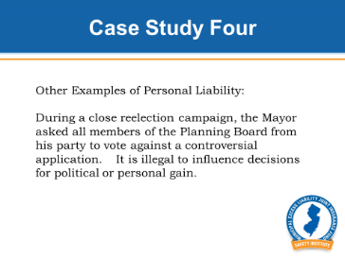
Slide 27 - Here are some other examples where immunity did not apply because of bad faith.

During a close reelection campaign, the Mayor asked all members of the Planning Board from his party to vote against a controversial application. It is illegal to influence decisions for political or personal gain. Those phone calls cost the tax payers hundreds of thousands of dollars.

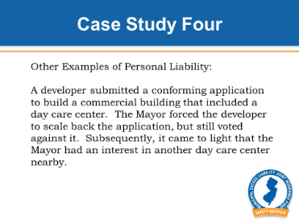
Slide 28 - In another example, a developer submitted a conforming application to build a commercial building that included a day care center. The Mayor forced the developer to scale back the application, but still voted against it. Subsequently, it came to light that the Mayor had an interest in another day care center nearby.

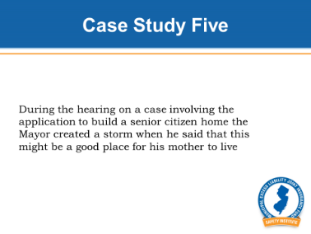
Slide 29 - Conflicts of interest can be tricky. For example, during the hearing on a case involving the application to build a senior citizen home the Mayor created a storm when he said that this might be a good place for his mother to live.

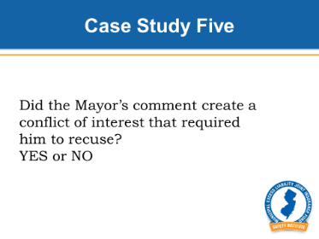
Slide 30 – Question 5: Did the Mayor’s comment create a conflict of interest that required him to recuse? YES or NO (pause)

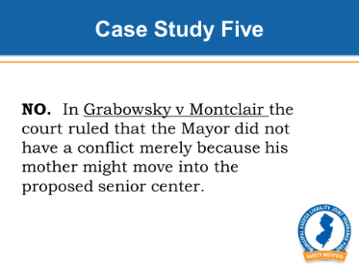
Slide 31 – NO. In Grabowsky v Montclair the court ruled that the Mayor did not have a conflict merely because his mother might move into the proposed senior center. However, the Mayor was also a board member of a church adjacent to the proposed senior center and therefore the Mayor’s vote was a conflict because of his relationship with the church.

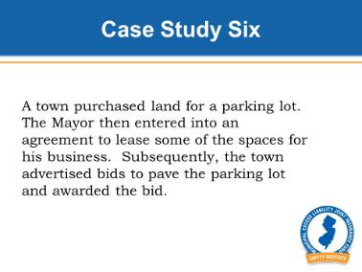
Slide 32 – Potential conflicts must be taken very seriously. In case 6, a town purchased land for a parking lot. The Mayor then entered into an agreement to lease some of the spaces for his business. Subsequently, the town advertised bids to pave the parking lot and awarded the bid.

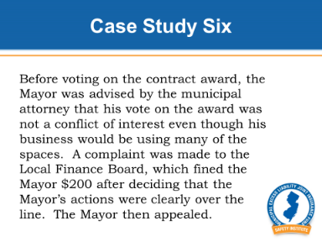
Slide 33 - Before voting on the contract award, the Mayor was advised by the municipal attorney that his vote on the award was not a conflict of interest even though his business would be using many of the spaces. A complaint was made to the Local Finance Board, which fined the Mayor $200 after deciding that the Mayor’s actions were clearly over the line. The Mayor then appealed.

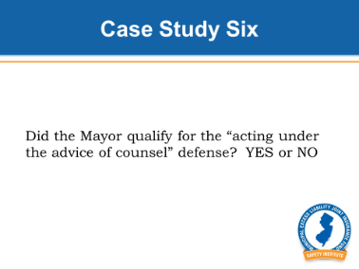
Slide 34 - In your opinion, did the Mayor qualify for the “acting under the advice of counsel” defense? YES or NO (pause)

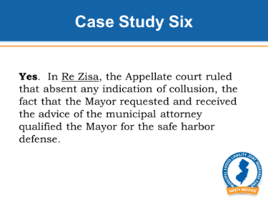
Slide 35 – Yes. In Re Zisa, the Appellate court ruled that absent any indication of collusion, the fact that the Mayor requested and received the advice of the municipal attorney qualified the Mayor for the safe harbor defense.

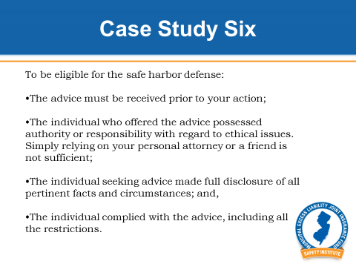
Slide 36 – Specifically, to be eligible for the safe harbor defense:

- The advice must be received prior to your action;

- The individual who offered the advice possessed authority or responsibility with regard to ethical issues. Simply relying on your personal attorney or a friend is not sufficient;

- The individual seeking advice made full disclosure of all pertinent facts and circumstances; and,

- The individual complied with the advice, including all the restrictions.

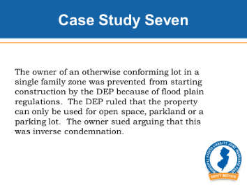
Slide 37 – In case 7, The owner of an otherwise conforming lot in a single family zone was prevented from starting construction by the DEP because of flood plain regulations. The DEP ruled that the property can only be used for open space, parkland or a parking lot. The owner sued arguing that this was inverse condemnation.

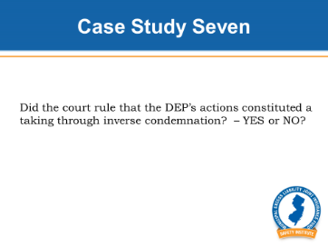
Slide 38 – Question: Did the court rule that the DEP’s actions constituted a taking through inverse condemnation? – YES or NO

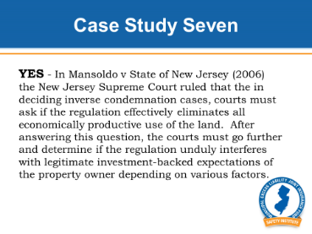
Slide 39 – YES: In Mansoldo v State of New Jersey (2006) the New Jersey Supreme Court ruled that the in deciding inverse condemnation cases, courts must ask if the regulation effectively eliminates all economically productive use of the land. After answering this question, the courts must go further and determine if the regulation unduly interferes with legitimate investment-backed expectations of the property owner depending on various factors. Based on this analysis, the court found that inverse condemnation occurred in this case and ultimately, the property owner sold the two lots to the town.

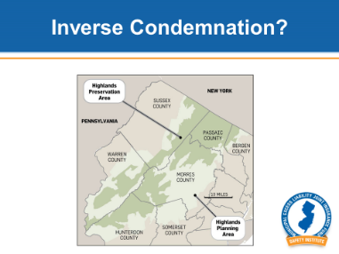
Slide 40 - Inverse Condemnation cases are complicated and very expensive to litigate. For example, the Highlands Water Protection and Planning Act effectively makes it very difficult to win approvals to develop in nine percent of the state. However, in drafting that legislation, the state added a provision to the law that allows the Highlands Protection and Planning Commission to grant waivers to property owners who can demonstrate inverse condemnation. As a result, owners must go through this appeal process before they can go to court. And as we all know, that process can take years.

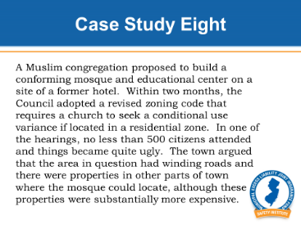
Slide 41 - In case 8, a Muslim congregation proposed to build a conforming mosque and educational center on a site of a former hotel. Within two months, the Council adopted a revised zoning code that required a church to seek a conditional use variance if located in a residential zone. In one of the hearings, no less than 500 citizens attended and things became quite ugly. The town argued that the area in question had winding roads and there were other properties where the mosque could locate, although these properties were substantially more expensive. The mosque argued that its consultant found that traffic would not be a problem and that the area already had educational and other similar uses.

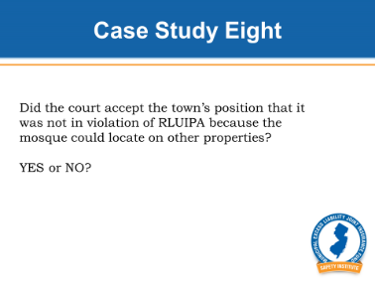
Slide 42 – Did the court accept the town’s position that it was not in violation of RLUIPA because the mosque could locate on other properties? YES or NO (pause)

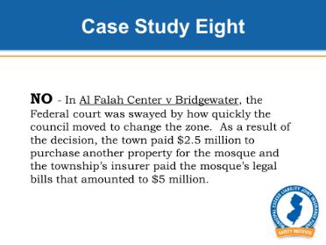
Slide 43 – NO: In Al Falah Center v Bridgewater, the Federal court was swayed by how quickly the council moved to change the zone. As a result of the decision, the town paid $2.5 million to purchase another property for the mosque and the township’s insurer paid the mosque’s legal bills that amounted to $5 million.

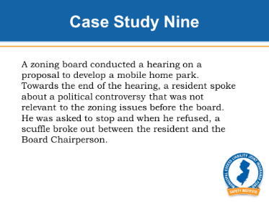
Slide 44 – In case study 9, a zoning board conducted a hearing on a proposal to develop a mobile home park. Towards the end of the hearing, a resident spoke about a political controversy that was not relevant to the zoning issues before the board. He was asked to stop and when he refused, a scuffle broke out between the resident and the Board Chairperson. Democracy can be messy.

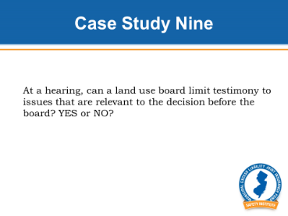
Slide 45 – At a hearing, can a land use board limit testimony to issues that are relevant to the decision before the board? YES or NO (pause)

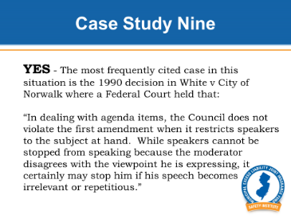
Slide 46 – YES: The most frequently cited case in this situation is the 1990 decision in White v City of Norwalk where a Federal Court held that:

“In dealing with agenda items, the Council does not violate the first amendment when it restricts speakers to the subject at hand. While speakers cannot be stopped from speaking because the moderator disagrees with the viewpoint he is expressing, it certainly may stop him if his speech becomes irrelevant or repetitious.”

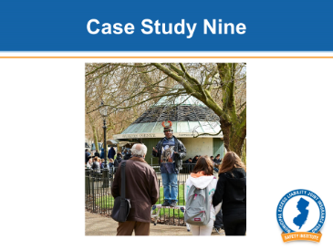
Slide 47 - Unlike a Council meeting, there is no requirement that a land use board reserve a portion of its meetings for open comment. A Board hearing is not Speakers Corner in Hyde Park.

By law, Boards can limit comment to issues that are relevant to what the board may consider in reaching its decisions. The board can also insist on decorum consistent with its status as a court. When a land use board allows a hearing to stray into inflammatory comments that are not relevant, it risks opening the town to a liability suit.

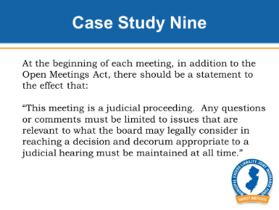
Slide 48 - At the beginning of each meeting, in addition to the Open Meetings Act, there should be a statement to the effect that:

“This meeting is a judicial proceeding. Any questions or comments must be limited to issues that are relevant to what the board may legally consider in reaching a decision and decorum appropriate to a judicial hearing must be maintained at all time.”

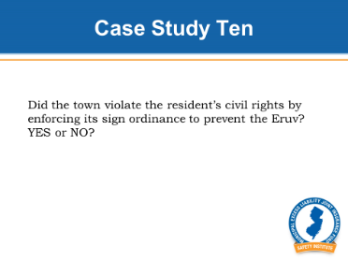
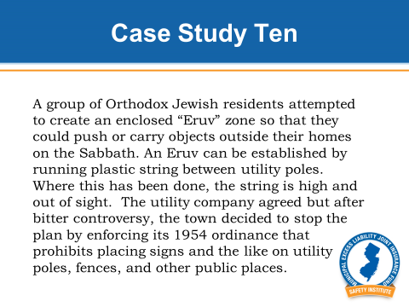
Slide 49 – In our last case, a group of Orthodox Jewish residents attempted to create an enclosed “Eruv” zone so that they could push or carry objects outside their homes on the Sabbath. Eruv’s were originally built with ropes and wooden poles, but today an Eruv can be established by running plastic string between utility poles. Were this has been done, the string is high and out of sight. The utility company agreed but after bitter controversy, the town decided to stop the plan by enforcing its 1954 ordinance that prohibits placing signs and the like on utility poles, fences, and other public places.

Slide 50 – Did the town violate the resident’s civil rights by enforcing its sign ordinance to prevent the Eruv? YES or NO (pause)

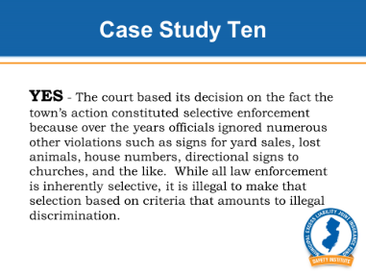
Slide 51 – YES: The court based its decision on the fact the town’s action constituted selective enforcement because over the years officials ignored numerous other violations such as signs for yard sales, lost animals, house numbers, directional signs to churches, and the like. While all law enforcement is inherently selective, it is illegal to make that selection based on criteria that amounts to illegal discrimination.

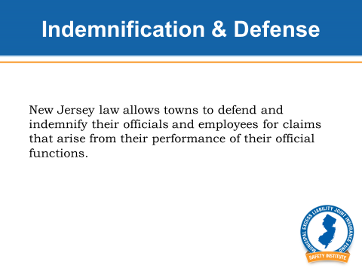
Slide 52 - Our final topic is indemnification and defense if you are sued. Fortunately, New Jersey law allows towns to defend and indemnify their officials and employees for claims that arise from their performance of their official functions. This can even include punitive damages and defense costs from criminal proceedings under some circumstances. The Council’s authority is very broad.

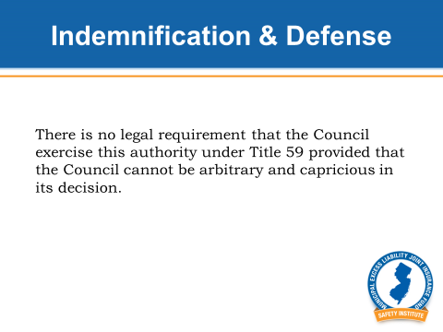
Slide 53 - However, there is no legal requirement that the Council exercise this authority under Title 59 provided that the Council cannot be arbitrary and capricious in its decision. Therefore, it cannot refuse indemnification to one individual for circumstances similar to something that it granted indemnification to another person.

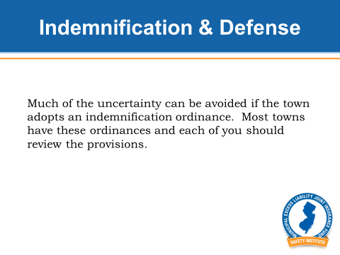
Slide 54 - Further, much of the uncertainty can be avoided if the town adopts an indemnification ordinance. Most towns have these ordinances and each of you should review the provisions. This is really your first line of defense. (Discuss the town’s indemnification ordinance)

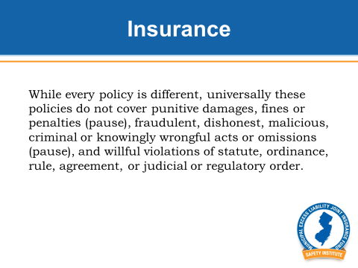
Slide 55 - What about insurance? Typically insurance only covers about half of the cost of these claims. To understand Public Officials Liability policies, you need to read the exclusions. While every policy is different, universally these policies do not cover punitive damages, fines or penalties, fraudulent, dishonest, malicious, criminal or knowingly wrongful acts or omissions, and willful violations of statute, ordinance, rule, agreement, or judicial or regulatory order. In fact, it is against state law for any insurance policy to cover intentional acts because such coverage would encourage wrongdoing. This is known as a moral hazard. It is significant that some of these things can be covered by the indemnification ordinance even if they can not be legally covered by the insurance policy.

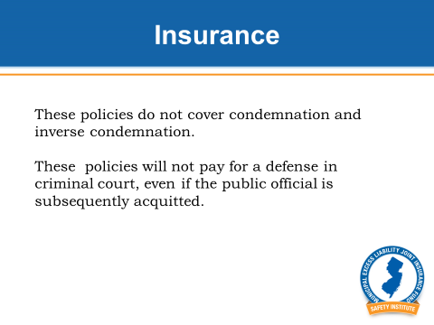
Slide 56 - And these policies do not cover condemnation and inverse condemnation which we also discussed earlier. Another point is that these policies will not pay for a defense in criminal court, even if the public official is subsequently acquitted. However, the indemnification ordinance may cover these defense costs depending on its terms.

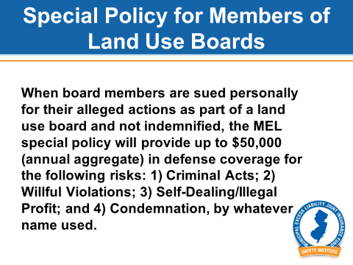
Slide 57 - The MEL provides a special policy to land use board members who complete this course. There is no premium because the purpose is to motivate members to attend this class. This special policy covers members personally for many cases that otherwise would be excluded under all other policies.

Specifically, when board members are sued personally for their actions as part of a land use board and not indemnified, the MEL special policy will provide up to $50,000 (annual aggregate) in defense coverage for the following risks: 1) Criminal Acts; 2) Willful Violations; 3) Self-Dealing/Illegal Profit; and 4) Condemnation, by whatever name used. HOWEVER, you will only be reimbursed under this policy if you are acquitted.

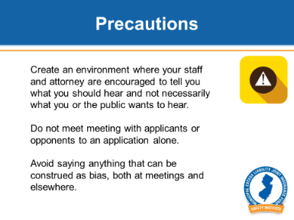
Slide 58 – Before we conclude there are several other precautions we should discuss.

- Create an environment where your staff and attorney are encouraged to tell you what you should hear and not necessarily what you or the public wants to hear. If there is litigation, be guided by the attorney representing you.

- Do not meet with applicants or opponents to an application alone.

- Avoid saying anything that can be construed as bias, both at meetings and elsewhere. For example, in one case a board member said at a contentious hearing: “We are not going to do anything that is contrary to the wishes of the public.” Comments like that make it very difficult to defend the board in court.

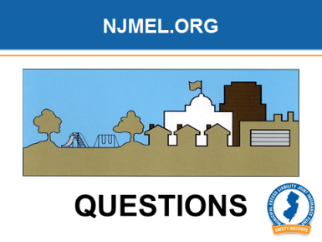
Slide 59 – Questions?

