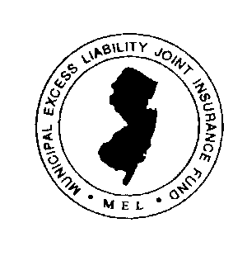
Municipal Excess Liability Joint Insurance Fund
9 Campus Drive, Suite 216
Parsippany, New Jersey 07054-4412

Tel (201) 881-7632
Fax (201) 881-7633
Member Municipalities June 11, 2018

Re: Land Use Liability

There has been a significant increase in suits against Planning and Zoning Boards alleging that their actions violate the civil rights. Currently the maximum coverage commonly available from commercial insurers for land use liability is $1 million because insurers are concerned that legitimate applications have been rejected because of vocal resident opposition.

Therefore, it is critical that all planners and zoners receive training to prevent land use liability claims. Attached is a script for a one-hour program that can be presented by your land use or municipal attorney. The PowerPoint slides can be downloaded from the MEL’s web site, NJMEL.org. In addition, the Funds will conduct regional training. There is no online program available for credit at this time because the MEL wishes to encourage an interactive dialogue.

To encourage board members to take this training, the MEL has just created a special policy to protect them from many personal exposures that are excluded in commercial policies. There is no additional premium for this special policy. To qualify for this coverage, your land use or municipal attorney must file the attached attendance form with the MEL office. Planners and zoners can also attend the course in other area communities. After the first of the year, courses will be scheduled in the area for newly appointed members.

Fortunately, personal lawsuits against land use board members are rare. Under the new policy, when a board member is sued personally for their official actions and is not otherwise indemnified, the MEL will reimburse the up to $50,000 (annual aggregate) for defense subject to the terms of the policy (copy attached). This coverage will also contribute towards a defense in criminal court, but only if the public official is subsequently acquitted.

There is no deadline to complete this training except that the training must be completed before the date of any acts that give rise to a claim. In the future, the MEL will provide refresher training that must be completed to retain the coverage.

As you know, for the past 15 years the MEL has conducted a successful risk management training program that is attended by 1500 local elected local officials each year. This new program for planners and zoners is an expansion of this concept.

Please feel free to contact your local JIF Executive Director or the MEL office.

David N. Grubb
Executive Director

Cc. MEL Board of Fund Commissioners Executive Directors of MEL affiliated JIFs
Fund Attorneys of MEL affiliated JIFs Risk Managers

