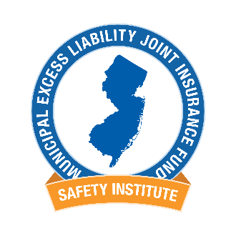
2019 Elected Officials Online Employment Practices Seminar

This course details ways to prevent Employment Practices lawsuits. Municipal elected officials, authority commissioners and a member's CEO (i.e. municipal manager / administrator or executive director) who completes this course by May 1, 2019 will qualify for a $250 credit in their local unit 2019 assessment.

- Click the following link for the MEL Safety Institute’s Learning Management System
www.firstnetcampus.com/meljif
- If you have previously taken MSI classes, enter your username and password. If you do not know your username/password, check with your Training Administrator or call the MSI Help Line.
If you are new, click ‘New User Registration.’ Complete the fields and you will receive an email with your username and password.
- Click on the On-Line Training Courses, at bottom right.
- Click the ‘2018-2019 Elected Officials’ Employment Practices Seminar’.
- Click ‘Enroll’.
- Click the ‘My Training’ tab on the top blue tool bar.
- Click the program name to launch the course.
- Upon completion of the course and questions you will navigate to the ‘Student Center’ tab to print your Certificate of Completion. Learning transcripts are automatically updated in the MEL Safety Institute’s Learning Management System.
Questions? Contact the MSI Help Line (866) 661-5120
The MEL Safety Institute can also be accessed anytime by going to www.njmel.org.
You must complete the entire program and the affidavit at the end of the program to receive credit. If you need additional assistance please call the MSI Help Line at (866) 661-5120 during business hours.

