MANAGERS AND SUPERVISORS (BASIC MUNICIPAL)
2019 - 20 RISK MANAGEMENT SEMINAR
(Draft dated October 8, 2019)

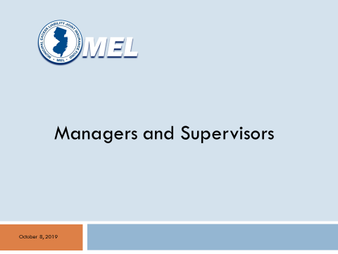
Slide 1 – Opening

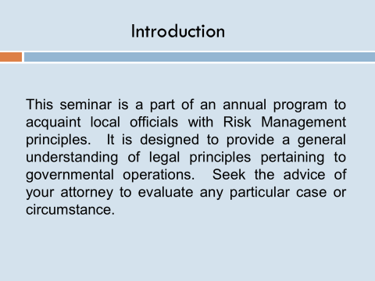
Slide 2 – This seminar is a part of a program to acquaint local officials with Risk Management principles. It is designed to provide a general understanding of legal principles pertaining to governmental operations. Seek the advice of your local unit attorney to evaluate any particular case or circumstance.

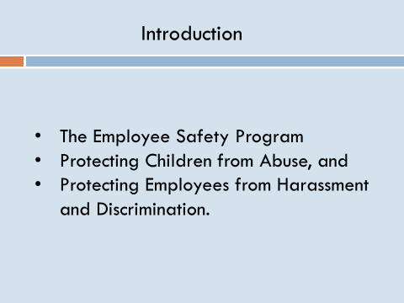
Slide 3 - In this seminar, we will discuss three topics:

- The Employee Safety Program
- Protecting Children from Abuse, and
- Protecting Employees from Harassment and Discrimination.

Section I: Employee Safety

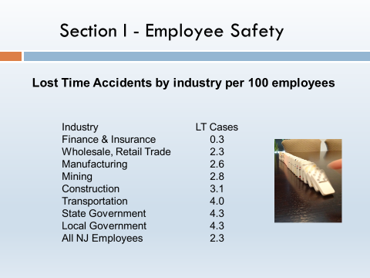
Slide 4 – Local government work is dangerous. In every state including New Jersey, local government has the highest accident rate of any employer classification. It is sobering to realize that the typical police officer, fire fighter or DPW worker has a higher accident frequency than either construction or underground mining.

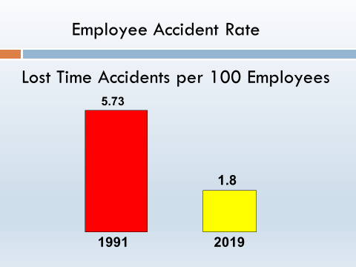
Slide 5 – Fortunately, management can substantially improve safety records. Since the formation of the MEL over 30 years ago, the accident rate for its members has been reduced 65% from 5.73 lost time accidents per 100 employees in 1991 to under 2.0 in 2017. This focus on safety has saved the taxpayers over $1.6 billion. More importantly, this effort resulted in thousands of local government workers who did not suffer a disabling injury who otherwise would have.

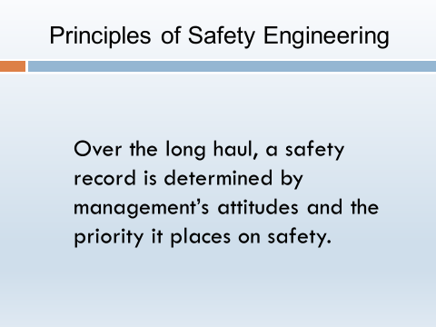
Slide 6 – How did we collectively achieve this record and what can we do to further improve? Let’s begin with the most basic principle. Over the long haul, a safety record is determined by management’s attitudes and the priority it places on safety. Management communicates its priorities by what it chooses to monitor or ignore.

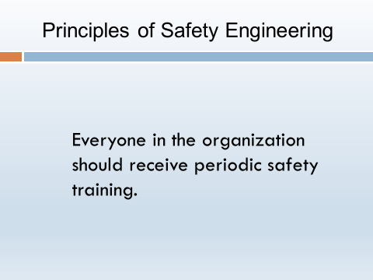
Slide 7 – For example, everyone in the organization should receive periodic safety training. On average, operations that are up to date with their safety training average 46% fewer accidents.

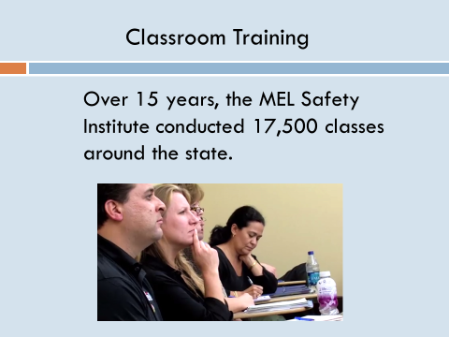
Slide 8 - 15 years ago, the MEL created the MEL Safety Institute to provide this training to members. Last year, 28,000 local unit employees and volunteers attended the Institute’s 1200 classes. Over the last 15 years, the Institute conducted 17,500 classes with an average of 22 attendees per class.

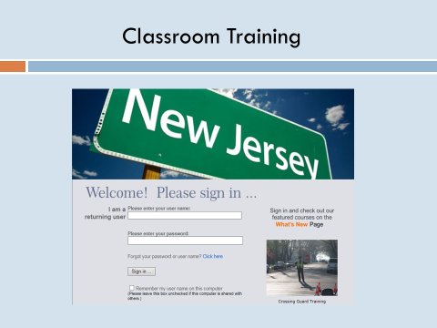
Slide 9 - Your employees and volunteers can register online for a class by clicking on the Institute’s learning management system. There is no charge…..the training fees are built into your premium. The learning management system also keeps track of each employee’s learning history.

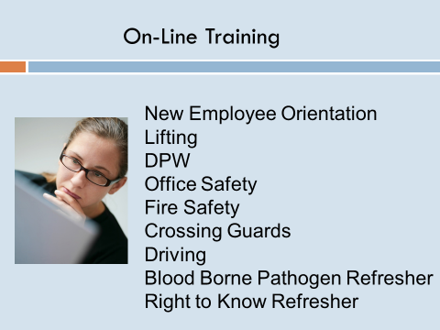
Slide 10 - The MEL Safety Institute also has online training that can be accessed on the MEL’s learning management system. Last year, 24,000 municipal employees took advantage of this convenient option.

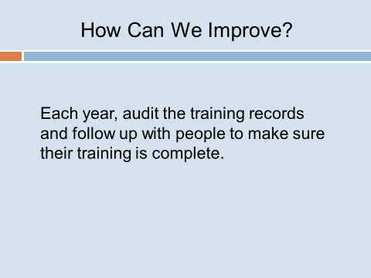
Slide 11 – How can we improve? Each year, audit the training records and follow up with people to make sure their training is complete.

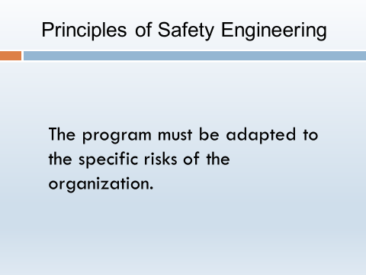
Slide 12 - The second principle is that the program must be adapted to the specific risks of the organization. A local unit of government is actually a number of different operations with different exposures. For this reason, The MEL’s safety representatives include certified safety professionals, along with experienced fire service officers and retired police command officers.
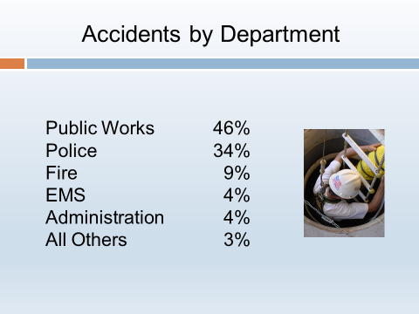
Slide 13 – 80% of the accidents occur in just two departments: public works (46%) and police (34%). The accidents rates for Fire and EMS operations are also significant. The MEL’s website includes a resource center that has a separate section for each major exposure.
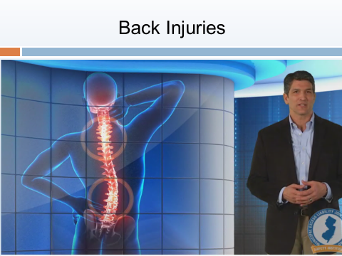
Slide 14 - For example, back injuries are a major problem in most municipal departments. However, the underlying causes are different for emergency responders as opposed to public works and utilities. For this reason, the MEL has developed several different back injury training programs, one for emergency responders and the other for other departments.
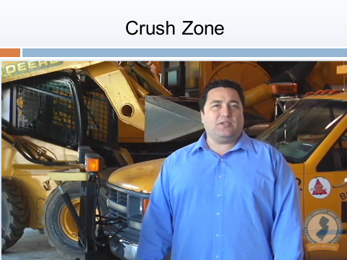
Slide 15 - Public works has a serious exposure to crush zone accidents in the garage, yard and out on the road. The MEL developed a program to specifically address this issue that won an international award.

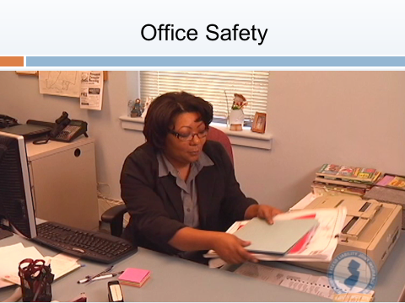
Slide 16 - The MEL also prepared a training program specifically for office staff.

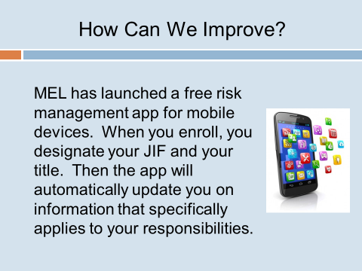
Slide 17 – How can we improve? To make it easier to access all of this information, MEL has launched a free risk management app for mobile devices. When you enroll, you designate your JIF and your title. Then the app will automatically update you on information that specifically applies to your responsibilities. You also have the option of signing up for multiple classifications. The simple directions are on the MEL’s website. We urge you to enroll as soon as this seminar is completed.

Section II: Protecting Children from Abuse.

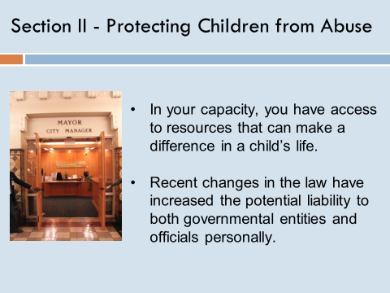
Slide 18 – The second topic for this year’s seminar is local government’s role in protecting children. Child abuse is a tough subject and protecting children must be one of local government’s top priorities.

This issue has recently rocked many venerable institutions including churches, sports programs, youth organizations and medical facilities. All local officials must address this problem as well. For example, municipalities run recreational programs and many operate day care centers. As a governmental official, you have a responsibility to address this issue. In fact, under recent legislation, you can be held personally responsible if you fail to act. We will discuss the liability issues in a few minutes.

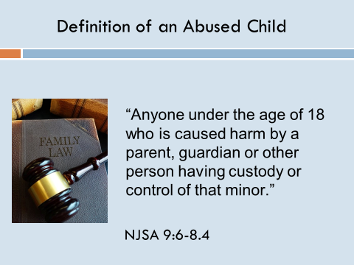
Slide 19 – Let’s first talk about who exactly is considered an abused or neglected child. The short answer is, anyone under the age of 18 who is caused harm by a parent, guardian or other person having custody or control of that minor. But more specifically, there are four common types of abuse:

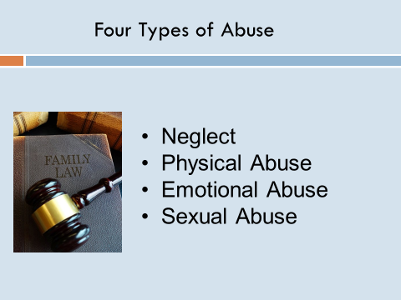
Slide 20 –

• The first we call neglect. That is the failure to meet a child’s basic needs: physically, medically or emotionally.

• Second is physical abuse. That’s defined as the intentional use of physical force that results in injury.

• Third is emotional abuse, the practice of behaviors that harm a child’s self-worth or emotional well-being.
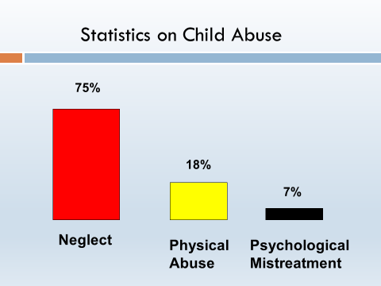
• And finally, sexual abuse which is engaging in sexual acts with a child including pornography.

Slide 21 - 75% of the cases involve neglect. 18% of victims are physically abused including sexual abuse. Psychological mistreatment accounts for 7%.

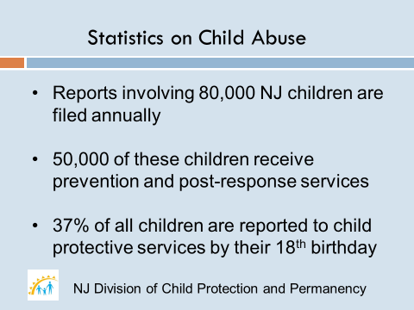
Slide 22 - Abuse in any of these forms is all too common.

• Here in New Jersey, abuse reports involving 80,000 children are filed each year with child protective services.

• 50,000 children receive prevention and post-response services.

• 37% of all children are reported to child protective services by their 18th birthday.

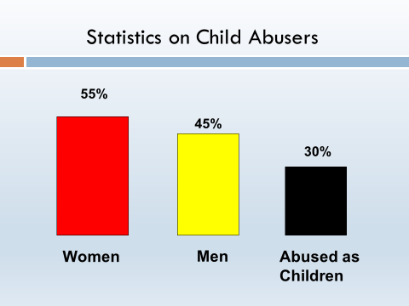
Slide 23 - 55% of the perpetrators in these cases are females while males account for the remaining 45%. What’s worse, some 30% of these abused children will later abuse their own children, creating a cycle of abuse that, in the United States alone, costs a staggering $585 billion each year.

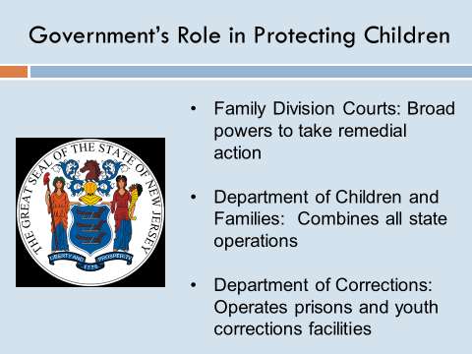
Slide 24 – What is the government’s role in protecting children? For the State of New Jersey, every level of government has a role.

• The State takes responsibility for enforcing the law through the New Jersey Family Division courts in each county seat. Courts are provided with broad powers, and can take remedial action including the removal of children from dangerous situations.

• The Department of Children and Families, and especially the Division of Child Protection and Permanency combine all state operations intended to safeguard children into a single, coordinated program working closely with the Courts and law enforcement.

• The Department of Corrections operates adult prisons and youth correctional centers to deal with perpetrators, while individual counties operate youth detention centers and special purpose schools.

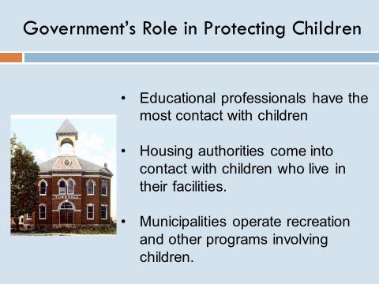
Slide 25 - At the local level, education professionals have the most contact with children, meaning they are often the first to detect issues. Housing Authorities come into contact with abused children as well, and municipalities operate recreational programs.

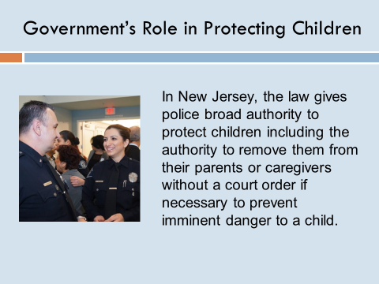
Slide 26 - The role of police agencies is especially important. They assist in resolving reported situations, often acting as the first identifiers. In New Jersey, the law gives police broad authority to protect children including the authority to remove them from their parents or caregivers without a court order if necessary to prevent imminent danger to a child.
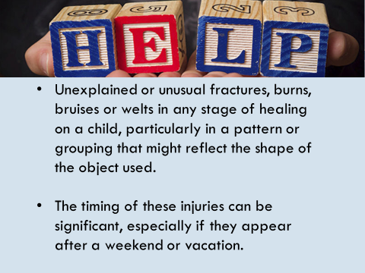
Slide 27 - Let’s talk about signs to look for and what they might mean. Some obvious indicators include:

• Unexplained or unusual fractures, burns, bruises or welts in any stage of healing on a child, particularly in a pattern or grouping that might reflect the shape of the object used.

• The timing of these injuries can be significant, especially if they appear after a weekend or vacation.

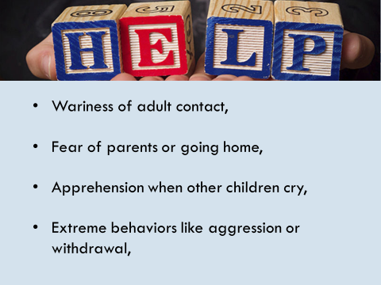
Slide 28 - A child’s behavior can also indicate potential abuse - things like:

• Wariness of adult contact,

• Fear of parents or going home,

• Apprehension when other children cry, or

• Extreme behaviors like aggression or withdrawal.

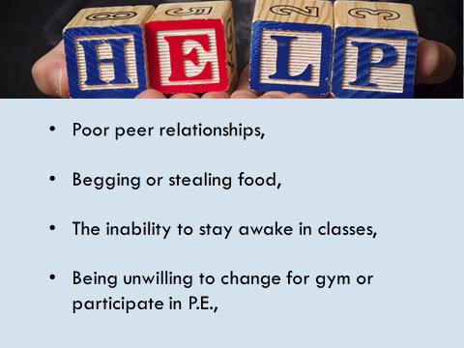
Slide 29 - Other indicators include:

• Poor peer relationships,

• Begging or stealing food,

• The inability to stay awake in classes.

• Being unwilling to change for gym or participate in P.E.

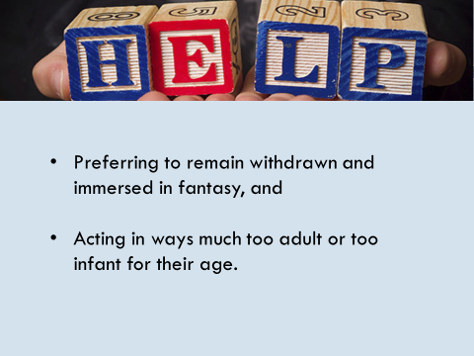
Slide 30 -

• Preferring to remain withdrawn and immersed in fantasy, and

• Acting in ways much too adult or too infant for their age.
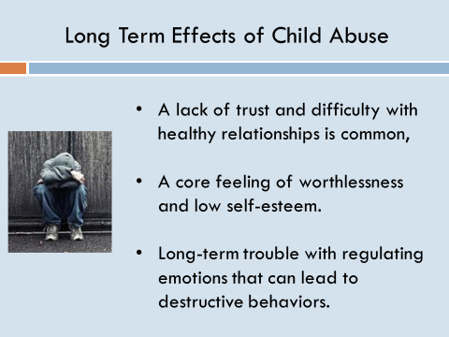
Slide 31 - As you could probably guess, child abuse can have long-term effects on victims. A lack of trust and difficulty with healthy relationships is common, as is a core feeling of worthlessness and low self-esteem. There may even be long-term trouble with regulating emotions that can lead to destructive behaviors.

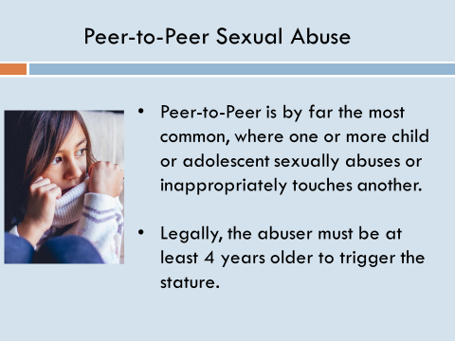
Slide 32 - Child sexual abuse is a particularly troubling topic. Peer-to-Peer is by far the most common, where one or more child or adolescent sexually abuses or inappropriately touches another. Legally, the abuser must be at least 4 years older to trigger the stature.

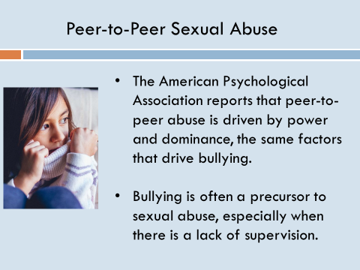
Slide 33 - The American Psychological Association reports this peer-to-peer abuse is driven by power and dominance, the same factors that drive bullying within this age group. In fact, bullying is often a precursor to sexual abuse, especially when there is a lack of supervision.

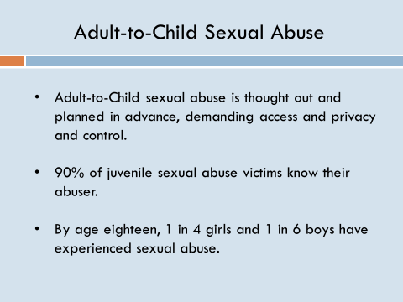
Slide 34 - In contrast, adult-to-child abuse is thought out and planned in advance, demanding access and privacy and control. These three factors demand a very specific type of relationship and setting, meaning that 90% of juvenile sexual abuse victims actually know their abuser. Let me say that again: 90% of juvenile sexual abuse victims know their abuser. The scope of the problem is massive: by age eighteen, 1 in 4 girls and 1 in 6 boys have experienced sexual abuse.
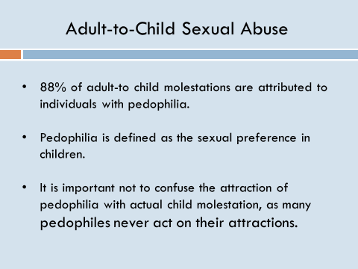
Slide 35 - 88% of these molestations are attributed to individuals with pedophilia. Pedophilia can be defined as the sexual preference for or strong interest in children. It is important, however, not to confuse the attraction of pedophilia with actual child molestation, as many pedophiles never act on their attractions.

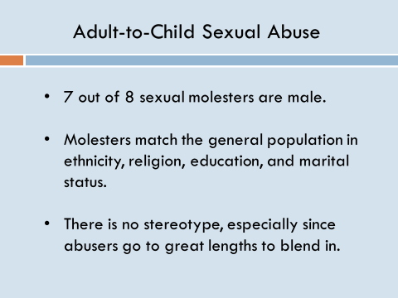
Slide 36 - Child sexual abusers are not always easy to spot. Though 7 out of 8 molesters are male, they match the general population in ethnicity, religion, education, and marital status. So there is no stereotype, especially since abusers go to great lengths to blend in.

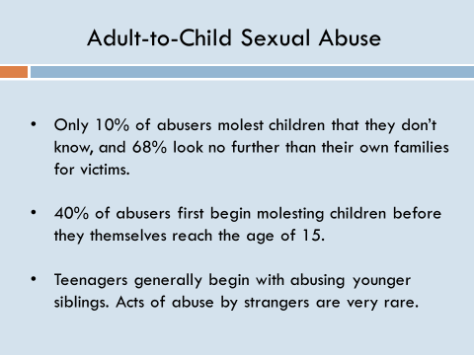
• Slide 37 - However, only 10% of abusers molest children that they don’t know, and 68% look no further than their own families for victims.

• It begins early. 40% of abusers first begin molesting children before they themselves reach the age of 15 and the vast majority before the age of 20.

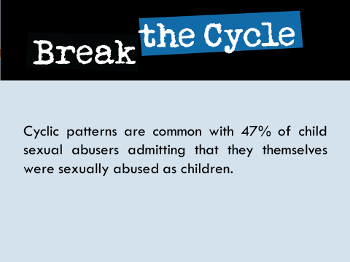
• These teenagers generally begin their acts of abuse on younger siblings. Acts of abuse by strangers are very rare.

Slide 38 - As in other forms of abuse, cyclic patterns are common with 47% of child abusers admitting that they themselves were sexually abused as children.

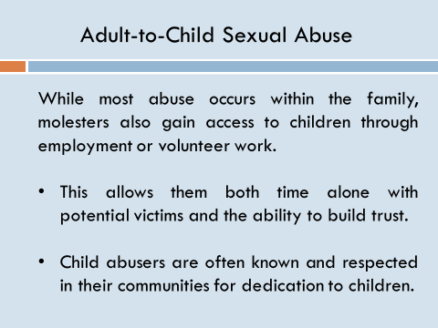
Slide 39 - Now, as we’ve said before, most abuse occurs within the family. However, molesters can gain access to children outside of their own families through employment or volunteer work with an organization that works primarily with children. This allows them both time alone with potential victims and the ability to build trust and credibility. In fact, child abusers are often known and respected in their communities for dedication to children.

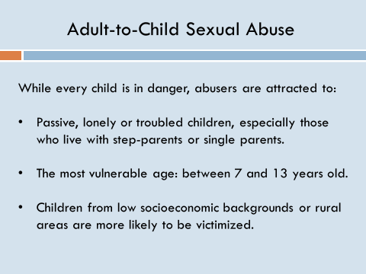
Slide 40 - When it comes to a victim profile, it is important to remember that, though there are characteristics that make some children more at risk, every child is in danger. Some specific characteristics that abusers look for?

• Passive, lonely or troubled children, especially those who live with step-parents or single parents.

• The most vulnerable age: between 7 and 13 years old.

• And children from low socioeconomic backgrounds or rural areas are more likely to be victimized.
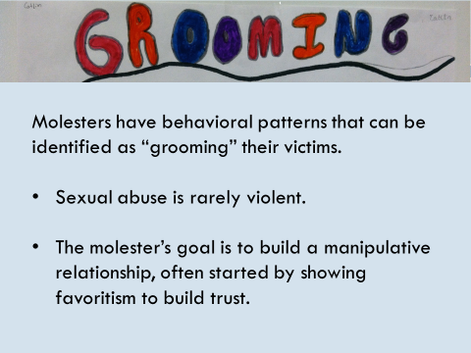
Slide 41 - Molesters themselves have behavioral patterns that can be identified as “grooming” their victims. Sexual abuse is rarely violent. The molester’s goal is to build a manipulative relationship, often started by showing favoritism to build trust.

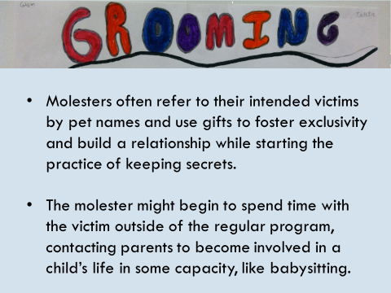
Slide 42 -

• Molesters often refer to their intended victims by pet names and use gifts to foster exclusivity and build a relationship while starting the practice of keeping secrets.

• The molester might begin to spend time with the victim outside of the regular program or schedule, contacting parents to become involved in a child’s life in some capacity, like babysitting. For this reason, many parents are shocked after abuse comes to light simply because the abuser seemed so good – too good to be true, in fact.

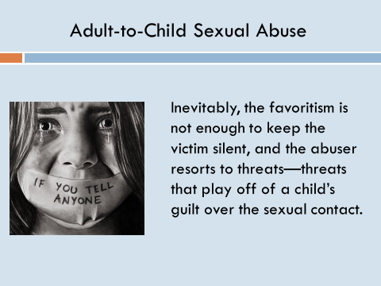
Slide 43 - Inevitably, the favoritism is not enough to keep the victim silent, and the abuser resorts to threats—threats that play off of a child’s guilt over the sexual contact.

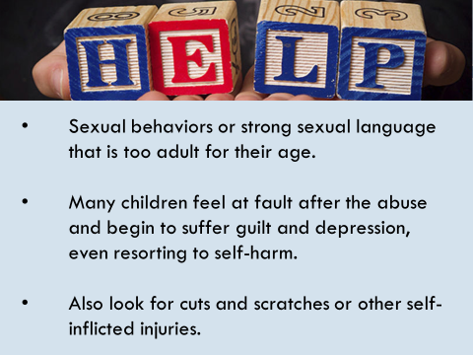
Slide 44 - During the grooming process and abuse itself, victims often begin to show tell-tale signs including:

• Sexual behaviors or strong sexual language that is too adult for their age.

• Many children feel at fault after the abuse and begin to suffer guilt and depression, even resorting to self-harm.
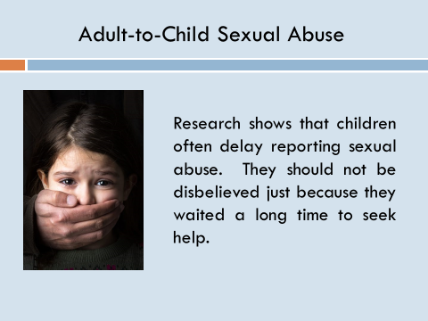
• Also look for cuts and scratches or other self-inflicted injuries.

Slide 45 – Research shows that children often delay reporting sexual abuse. They should not be disbelieved just because they waited a long time to seek help.

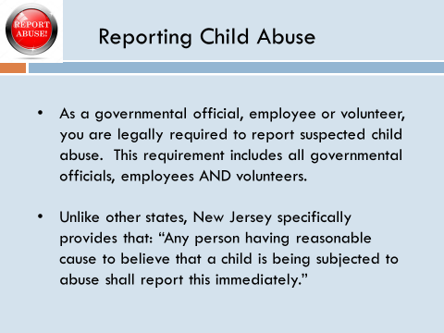
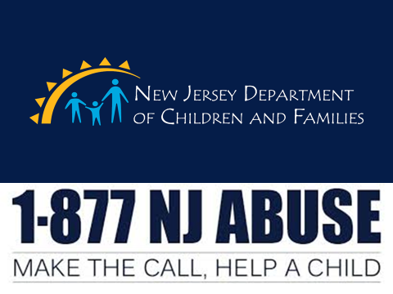
Slide 46 - What can we do to help an abused or neglected child? As a governmental official, employee or volunteer, you are legally required to report suspected child abuse. This requirement includes all governmental officials, employees AND volunteers. In fact, unlike other states, New Jersey law specifically provides that: “Any person having reasonable cause to believe that a child is being subjected to abuse shall report this immediately.”

Slide 47 - The Department of Children and Families maintains a hot line to report child abuse. The number is: 1 877 NJ ABUSE (652-2873) Failure to report is a misdemeanor. It can also expose yourself to a law suit for damages.
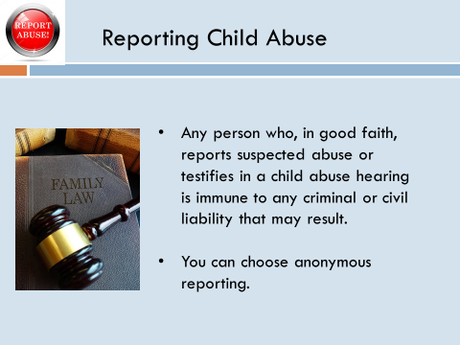
Slide 48 - The good news is that any person who, in good faith, reports suspected abuse or testifies in a child abuse hearing is immune to any criminal or civil liability that may result. And you need to know that you can choose anonymous reporting as well.

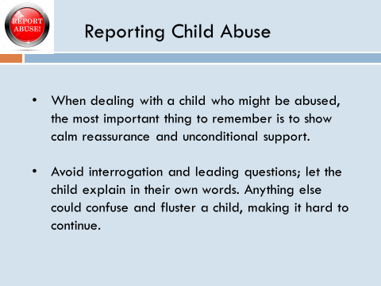
Slide 49 - When dealing with a child who might be abused, the most important thing to remember is to show calm reassurance and unconditional support.

• Avoid interrogation and leading questions; let the child explain in their own words. Anything else could confuse and fluster a child, making it hard to continue.
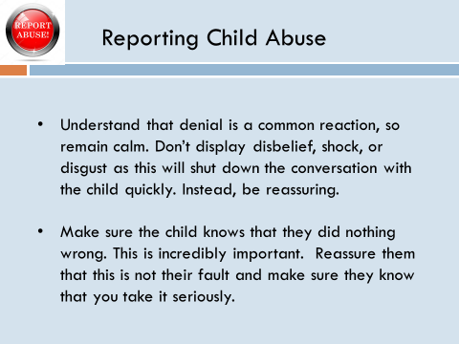
Slide 50 -

• Understand that denial is a common reaction, so remain calm. Don’t display disbelief, shock, or disgust as this will shut down the conversation with the child quickly. Instead, be reassuring.

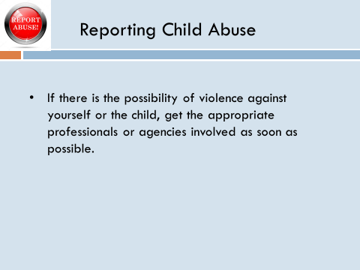
• Make sure the child knows that they did nothing wrong. This is incredibly important. Reassure them that this is not their fault and make sure they know that you take it seriously.

Slide 51 - And finally, if there is the possibility of violence against yourself or the child, get the appropriate professionals or agencies involved as soon as possible.

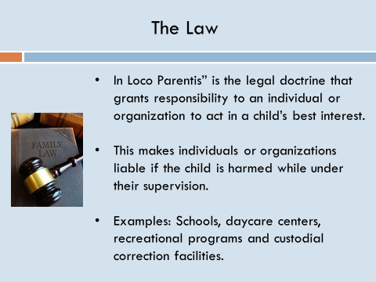
Slide 52 – Now we will discuss the liability issues in greater detail. The term “In Loco Parentis” is a legal doctrine that grants responsibility to an individual or organization to act in a child’s best interest. This makes individuals or organizations liable if the child is harmed while under their supervision. Examples of “in Loco Parentis” include schools, daycare centers, recreational programs and custodial correctional facilities.

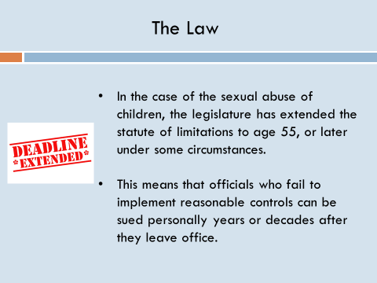
Slide 53 - In the case of the sexual abuse of children, the legislature has extended the statute of limitations to age 55, or later under some circumstances. This means that officials who fail to implement reasonable controls can be sued personally years or decades after they leave office.

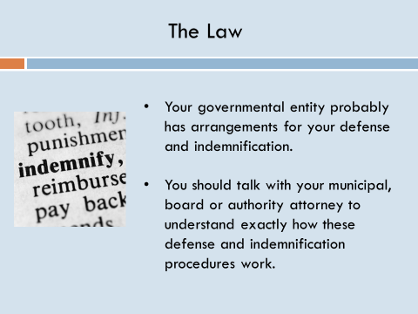
Slide 54 - Before you become overly concerned, your governmental entity probably has arrangements for your defense and indemnification. However, you should talk with your municipal, board or authority attorney to understand exactly how these defense and indemnification procedures work.

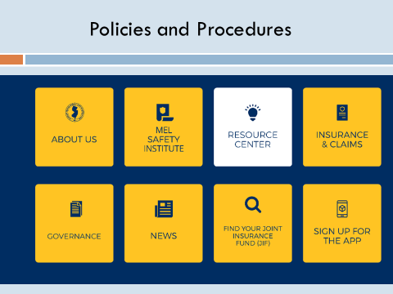
Slide 55 – The point is that all governmental entities must have policies and procedures to deal with child abuse. A model policy and procedure can be found in the resource center on the MEL web site.

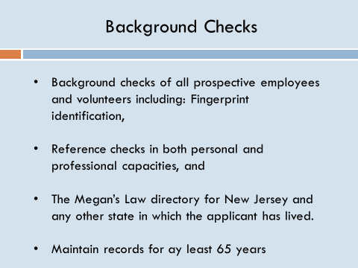
Slide 56 - These procedures must start with background checks of all prospective employees and volunteers including:

• Fingerprint identification,

• Reference checks in both personal and professional capacities, and

• The Megan’s Law directory for New Jersey and any other state in which the applicant has lived.

Written documentation of these checks should be kept for at least 65 years.

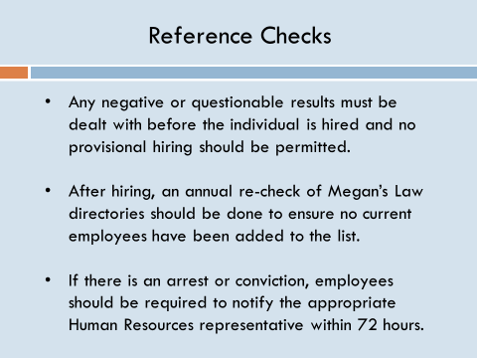
Slide 57 -

• Any negative or questionable results must be dealt with before the individual is hired or begins to work with minors, and no provisional hiring should be permitted.

• After hiring, an annual re-check of Megan’s Law directories should be done to ensure no current employees have been added to the list.

• If there is an arrest or conviction, employees should be required to notify the appropriate Human Resources representative within 72 hours.

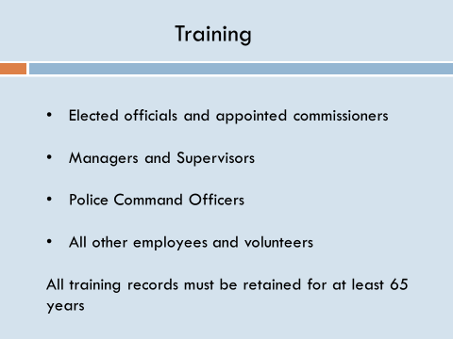
Slide 58 – Next, everyone must be trained, beginning with elected officials. This is the purpose of this seminar. Remember, if anything happens, you will be personally sued which means you will probably be deposed and may have to testify in court.

• For all managers and supervisors your joint insurance fund will provide this training.

• There will be a special training course for police command officers.

• Your JIF will also provide an on line program for all other employees and volunteers.

• It is critical that the records documenting this training be retained for at least 65 years. This is one of the advantages of the MEL’s on line learning management system referenced earlier in this seminar.
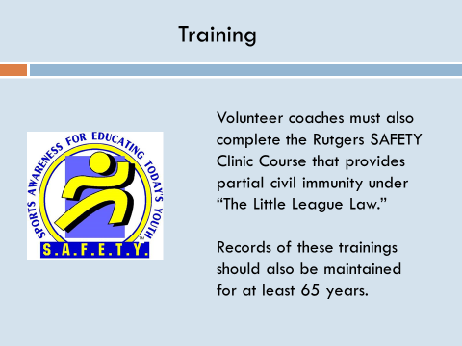
Slide 59 - volunteer coaches must also complete the Rutgers SAFETY Clinic Course that provides partial civil immunity under “The Little League Law.” Again, records of all these trainings should be maintained for at least 65 years.

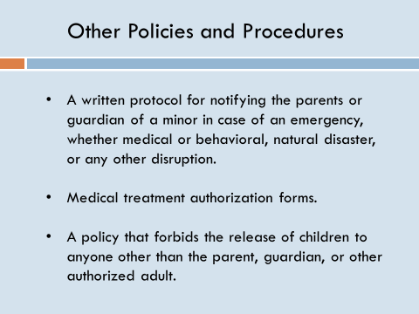
Slide 60 - In addition to vetting and training, policies should include:

• A written protocol for notifying the parents or guardian of a minor in case of an emergency, whether medical or behavioral, natural disaster, or any other disruption.

• Medical treatment authorization forms, and

• A policy that forbids the release of children to anyone other than the parent, guardian, or other authorized adult.

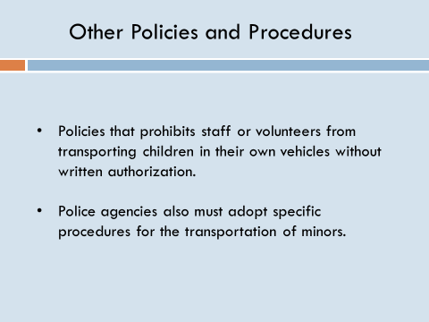
Slide 61 - It is also advisable to implement policies that prohibit staff or volunteers from transporting children in their own vehicles without written authorization. Police agencies also must adopt specific procedures for the transportation of minors.

Slide 62 – In addition:
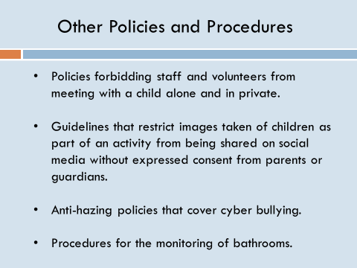
• Strong policies should be in place forbidding staff and volunteers from meeting with a child alone and in private.

• Guidelines should be laid out that restrict images taken of children as part of an activity from being shared on social media or any other platform without expressed consent from parents and guardians, and

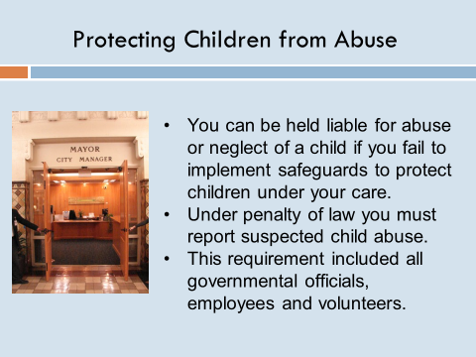
• Anti-Hazing and bullying policies that cover cyber bullying should be instituted as well as procedures for the monitoring of bathroom facilities

Slide 63 – In conclusion, let me again reiterate that you can be held liable for the abuse or neglect of a child if you fail to implement safeguards to protect children under your care. This also means that under penalty of law you must report suspected child abuse. This requirement includes all governmental officials, employees AND volunteers.

Slide 64 - The Department of Children and Families maintains a hot line to report child abuse. The number is: 1 877 NJ ABUSE (652-2873). You can choose anonymous reporting as well.
Section III: Protecting Employees from Harassment and Discrimination:

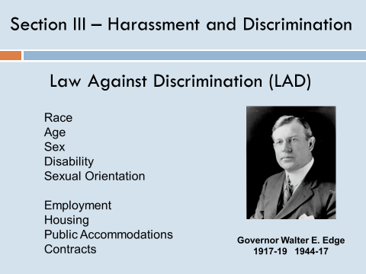
Slide 65 – In the third section, we will focus on Protecting Employees from Harassment and Discrimination. New Jersey’s Law against Discrimination, known as LAD, dates back to 1945 and was the first such statute in the country. Over the last 75 years the act has been amended numerous times to add protections based age, sex, disability, sexual orientation, gender identity and pregnancy. The law was expanded to cover not just employment discrimination, but also unlawful discrimination in housing, places of public accommodations, the provision of services and terms of contracts. In today’s discussion, we are going to focus on employment practices.

Slide 66 - In early years, most employment suits against local government involved equal opportunities. In particular, women and other minorities were forced to use the courts to break into local government. Fortunately, we don’t see as many of these suits today because people have become more sensitive to the requirements of these laws.

While overt racial or gender discrimination is rare in the public sector, disparate treatment is more common. In one case, a minority employee was terminated at the end of the probation period for poor performance. Subsequently, it was determined that non-minority employees were allowed to continue in the past with equally poor performance reviews. While it is perfectly legal to terminate someone for poor performance at the end of the probation period, it has to be done consistently.

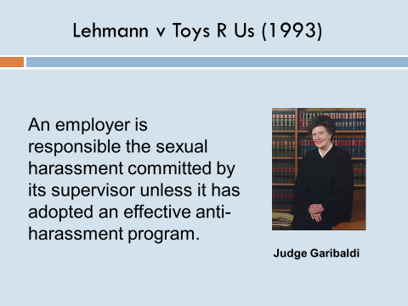
Slide 67 - In 1993, the New Jersey Supreme Court extended LAD to include on the job harassment in its landmark decision in Lehmann v Toys R Us. In fact, much of the harassment we hear about today has been illegal in New Jersey or 25 years. In its decision, the Court ruled that an employer is responsible for sexual harassment committed by its supervisory employees unless it had an effective anti-harassment program. The key word here is effective.

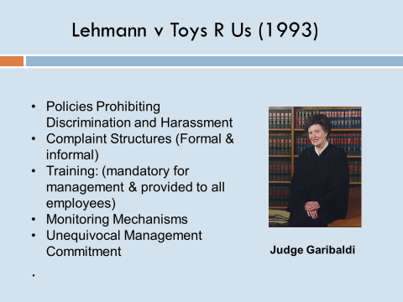
Slide 68 - The court established specific guidelines for what an employer must put in place. Specifically:

• Written policies and procedures prohibiting discrimination and harassment in the workplace. The MEL has responded by developing a model employment policies and procedures manual that is available on the website. This manual is updated every two years.

• Both formal and informal employee complaint procedures. This is included in the model manual;

• Training: which must be mandatory for management personnel and provided to all other employees. Every two years the MEL develops a training program specifically for managers and supervisors. The MEL also distributes an updated training program for non-managerial personnel. The program along with an instructor’s guide is available on the MEL’s website and DVD copies are distributed at no charge to MEL members.

• A system to monitor compliance “to make sure the complaint structure is trusted”. It is good practice to task someone in senior management to periodically talk to employees and ask if they have experienced harassment, and

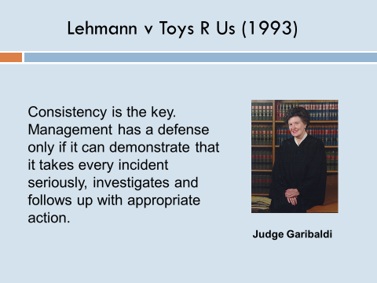
• An unequivocal commitment from senior management that is not just words but backed up by consistent practice.

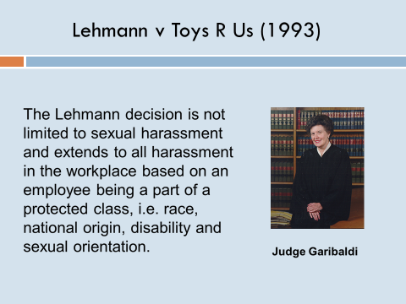
Slide 69 – Consistency is the key. Management has a defense only if it can demonstrate that it takes every incident seriously, investigates and follows up with appropriate action.

Slide 70 - Further, the Lehmann decision is not limited to sexual harassment and extends to all harassment in the workplace based on an employee being a part of a protected class. For example, the principle applies to race, national origin, disability and sexual orientation.

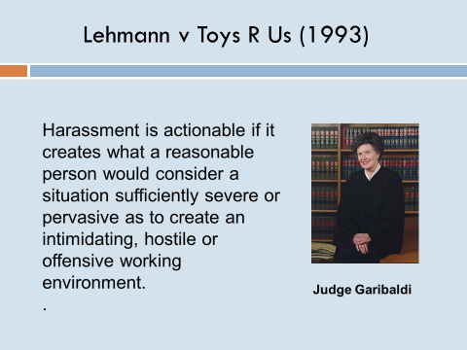
Slide 71 - Such harassment is actionable if it creates what a reasonable person would consider a situation sufficiently severe or pervasive as to create an intimidating, hostile or offensive working environment.

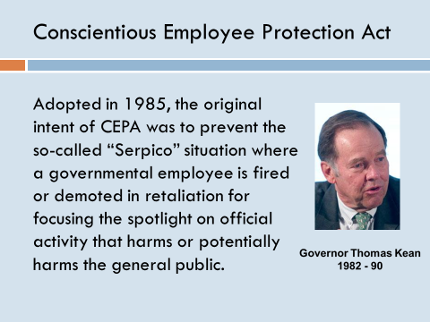
Slide 72 - In recent years, we have also seen a dramatic expansion of cases alleging violations of CEPA – the Conscientious Employee Protection Act also known as the Whistle Blowers Act. Adopted by the New Jersey legislature in 1985, the original intent of CEPA was to prevent the so-called “Serpico” situation where a governmental employee is fired or demoted in retaliation for focusing the spotlight on official activity that harms or potentially harms the general public.
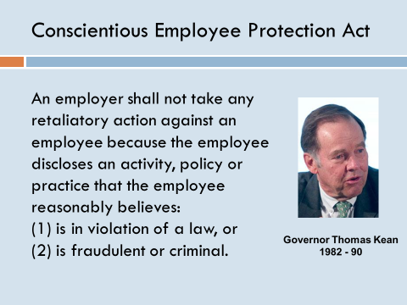
Slide 73 - Act provides that:

“An employer shall not take any retaliatory action against an employee because the employee discloses an activity, policy or practice that the employee reasonably believes:
(1) is in violation of law…..or
(2) is fraudulent or criminal.
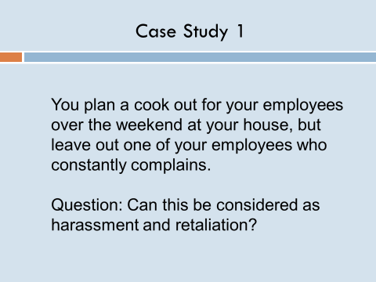
Slide 74 - Now let’s talk about some specific examples. Let’s say you plan a cook out for your employees over the weekend at your house, but leave out one of your employees who constantly complains.

Question: Can this be considered as harassment and retaliation?

Answer: Yes, at least here in New Jersey.

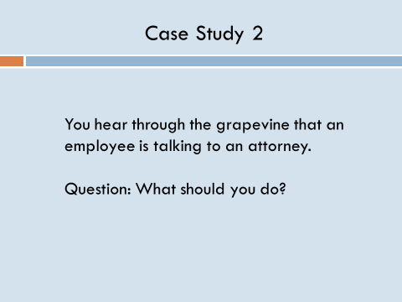
Slide 75 – Let’s say you hear through the grapevine that an employee is talking to an attorney.

Question: What should you do?

Answer: Do not confront the employee. Instead, consult your Personnel Policy and Procedure Manual and talk to the person in your organization responsible for personnel matters.

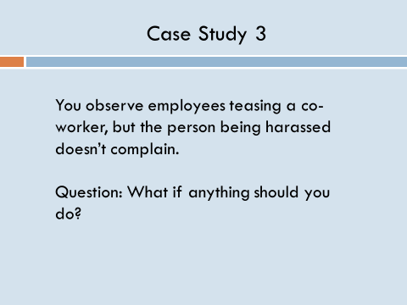
Slide 76 – In Example 3, you observe employees teasing a co-worker, but the person being harassed doesn’t complain.

Question: What if anything should you do?

Answer: You cannot ignore the problem. Talk to the person you report to or the person in your organization responsible for personnel matters.

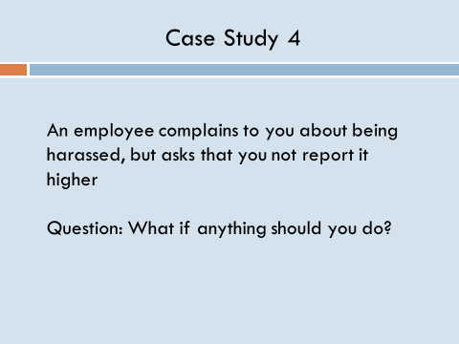
Slide 77 - An employee complains to you about being harassed, but asks that you not report it higher

Question: What if anything should you do?

Answer: Again, you cannot ignore this situation even if the employee asks that you not do anything. You still must talk to the person you report to or the person in your organization responsible for personnel matters.

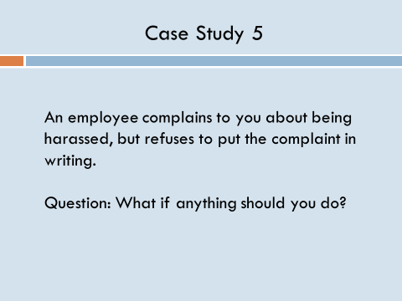
Slide 78 - An employee complains to you about being harassed, but refuses to put the complaint in writing.

Question: What if anything should you do?

Answer: Employees cannot be required to put complaints in writing. You must handle both verbal and written complaints exactly the same way.

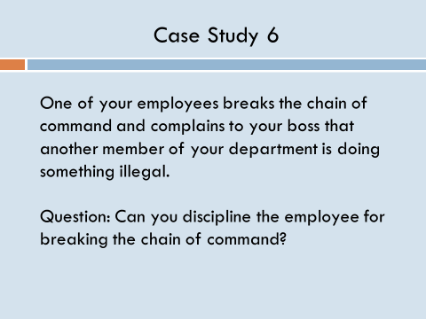
Slide 79 - One of your employees breaks the chain of command and complains to your boss that another member of your department is doing something illegal.

Question: Can you discipline the employee for breaking the chain of command?

Answer: Absolutely NO. Do not even talk to the employee about breaking the chain of command. It is the employee’s right to complain directly to whomever the employee feels most comfortable. Disciplining an employee for complaining to higher ups is a clear violation of whistle blowers protection act.

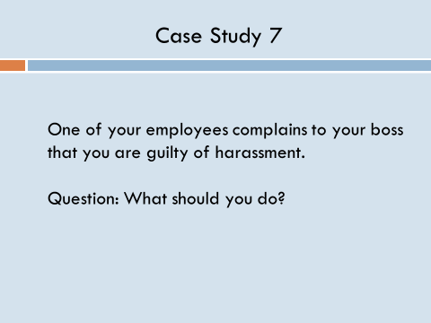
Slide 80 - One of your employees complains to your boss that you are guilty of harassment.

Question: What should you do?

Answer: You have to be especially careful in this situation. Do not confront the employee or even talk to the employee about the complaint. Seek the advice of the person in your organization responsible for personnel matters.

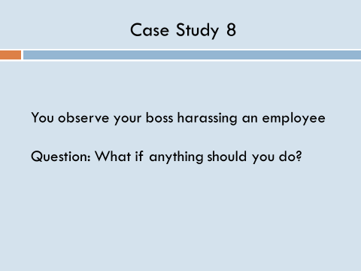
Slide 81 - You observe your boss harassing an employee

Question: What if anything should you do?

Answer: As a manager or a supervisor, you are obligated to report this. Follow your organization’s reporting procedure in the personnel policies and procedures manual. Under the law, you are also protected from harassment or retaliation for reporting wrong doing.

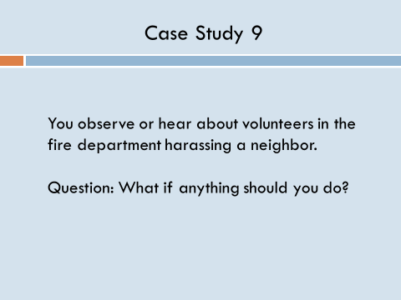
Slide 82 - You observe or hear about volunteers in the fire department harassing a neighbor.

Question: What if anything should you do?

Answer: You cannot ignore this situation either. Follow your organization’s reporting procedure in the personnel policies and procedures manual.

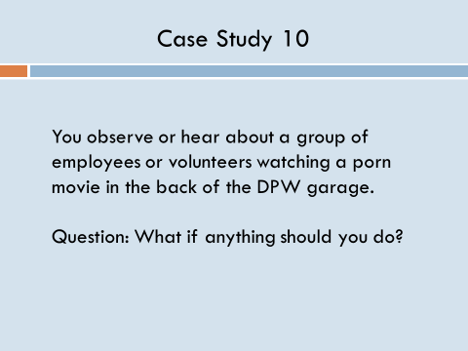
Slide 83 - You observe or hear about a group of employees or volunteers watching a porn movie in the back of the DPW garage.

Question: What if anything should you do?

Answer: This must be reported as well.

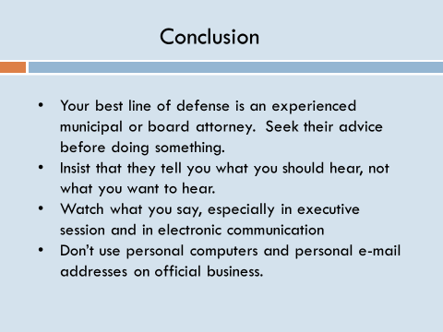
Slide 84 –

• Your best line of defense is an experienced municipal or board attorney. Seek their advice before doing something.

• Insist that they tell you what you should hear, not what you want to hear.

• Watch what you say, especially in executive session and in electronic communication

• Don’t use personal computers and personal e-mail addresses on official business.

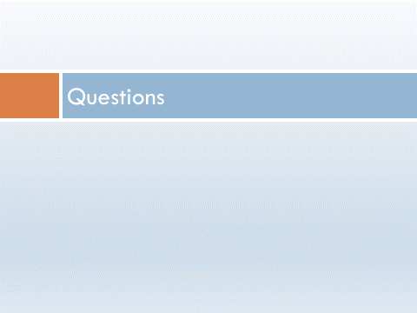
Slide 85 – Questions?

