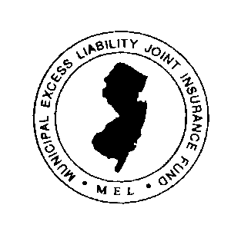
Municipal Excess Liability Joint Insurance Fund
Office of the Fund Attorney
714 Main Street

P.O. Box 228

Boonton, New Jersey 07005
Tel (973) 334-1900
fsemrau@dorseysemrau.com

BULLETIN

TO: All Members

FROM: Fred Semrau, Fund Attorney
Dave Grubb, Executive Director
Joseph Hrubash, Executive Director

DATED: March 24, 2021

RE: New Jersey Cannabis Legislation – Legal Update

Some of our members have inquired about the recently enacted New Jersey legislation pertaining to recreational cannabis, as it relates to local licensing and zoning. Municipalities have until August 21, 2021 to make critical zoning decisions as to the six different cannabis licenses that have been established by our Legislature. While recreational cannabis use is now legal throughout the State, certain aspects regarding its cultivation, manufacturing, wholesaling, distribution, retail sales and delivery involve decisions that may be made on the local level.

Unless a community formally opts out of some or all of the above types of recreational cannabis businesses by adopting an “opt out” ordinance by the August 21, 2021 deadline, it will be deemed to have opted in for same and in locked in for a period of five years. During the five-year period, the community cannot reverse its opt-in status and if a recreational cannabis business opens, it cannot be legislated out after the five years. On the other hand, communities that opt-out of certain cannabis business activity may reverse that decision at any time by adopting a revised ordinance.

If your community wishes to consider opting-out of certain business type before August 21, 2021, we encourage you to share this draft ordinance with your Municipal Attorney and Planner as a starting point. It is critical that your Governing Body discusses these important policy considerations and acts prior to August 21, 2021 on cannabis licenses and local zoning.

As to employment concerns, the MEL recommends an update on employment practices policy considerations regarding cannabis. With respect to commercial driver’s license (CDL) and non-CDL driver policies, we encourage you to visit the MEL website at https://njmel.org/mel-safety-institute/model-policies/driver-policies/ for additional suggested policy information.

The MEL will continue to monitor recreational cannabis legislation and provide information as to its impact on our members.

